**Soldering Workshop**

Created by Connor Sheeran, Mark Webster, and Ousema Zayati

January 2019 Sacramento City College Makerspace

***Summary***: Learn how to solder to create electrical circuits and prototype circuit boards

Learn how to solder to create a working LED circuit and a method to splice wires together. Along the way you’ll learn about the tools, components and methods related to electrical connections.

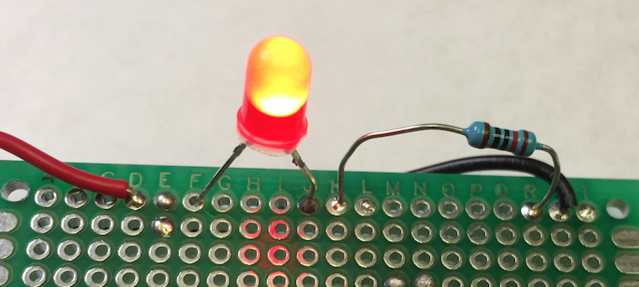

## Introduction

Soldering is making an electrical and physical connection, an intermolecular bond using heat and metals! Soldering is a demonstration of physics and chemistry because a new metal alloy is created using solder and the metal of other components.

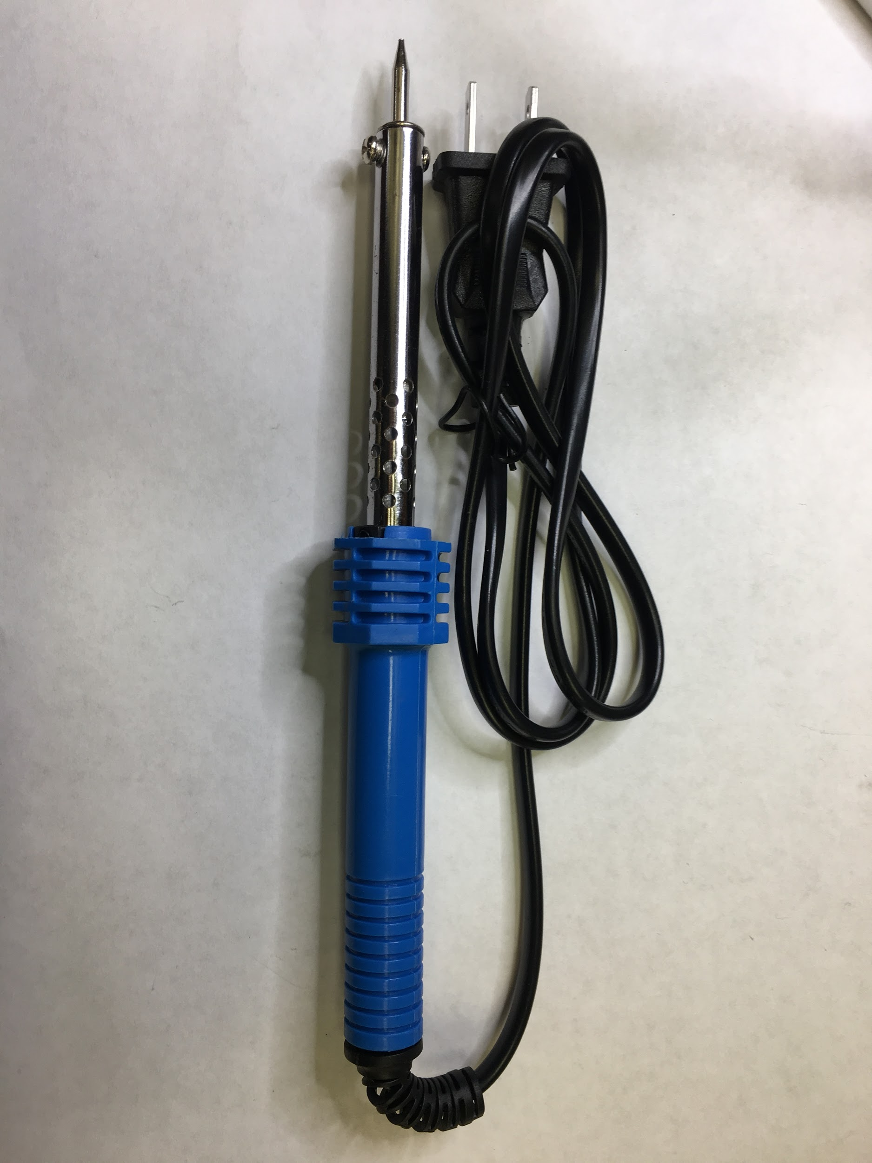 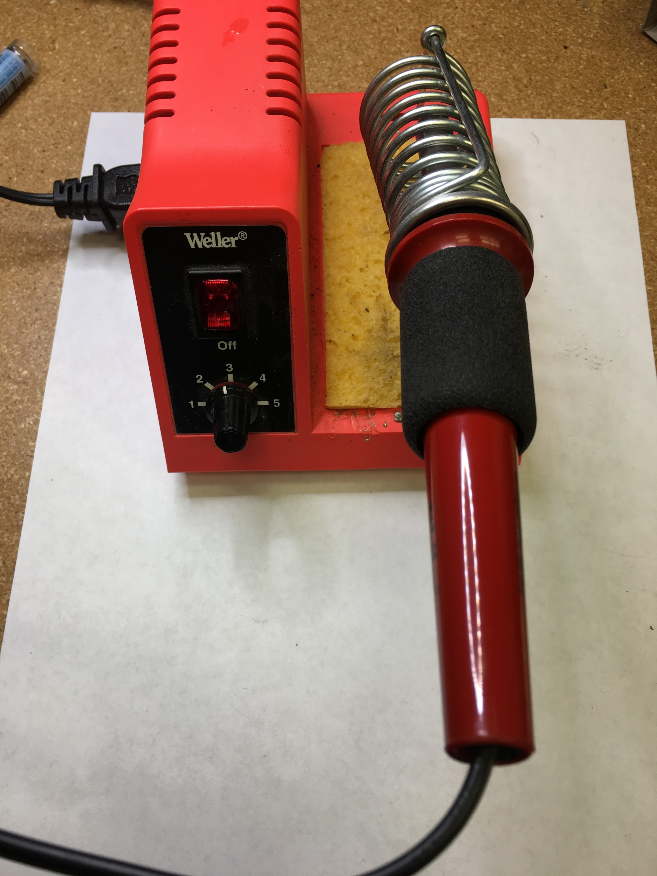

Pictured is a 30- 40w soldering iron (left), and a 80-100w soldering iron with temperature control (right). *Tip: Temperature control for the 30-40w iron can be accomplished with a Rheostat.*

(**Insert Photo** of Soldering iron tips, lead / lead free / rosin core solder)

## Types of electrical connections

Soldering all connections isn’t a solution for all electrical connections, some mechanical method connections work well in other environments, e.g. Connections that need to be disassembled regularly to for maintenance or repair of larger systems. Soldering works well for small components and circuits intended to be semi-permanent.

Examples of other types of connections:

Breadboard with jumper wires 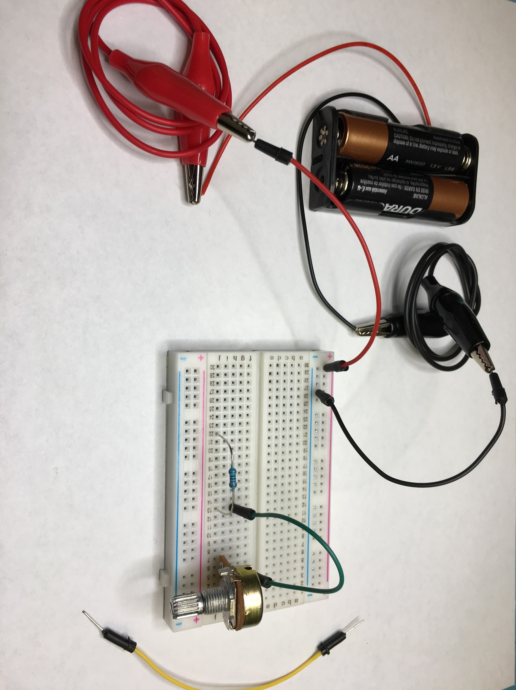

Solder pads on a circuit board Crimped terminals

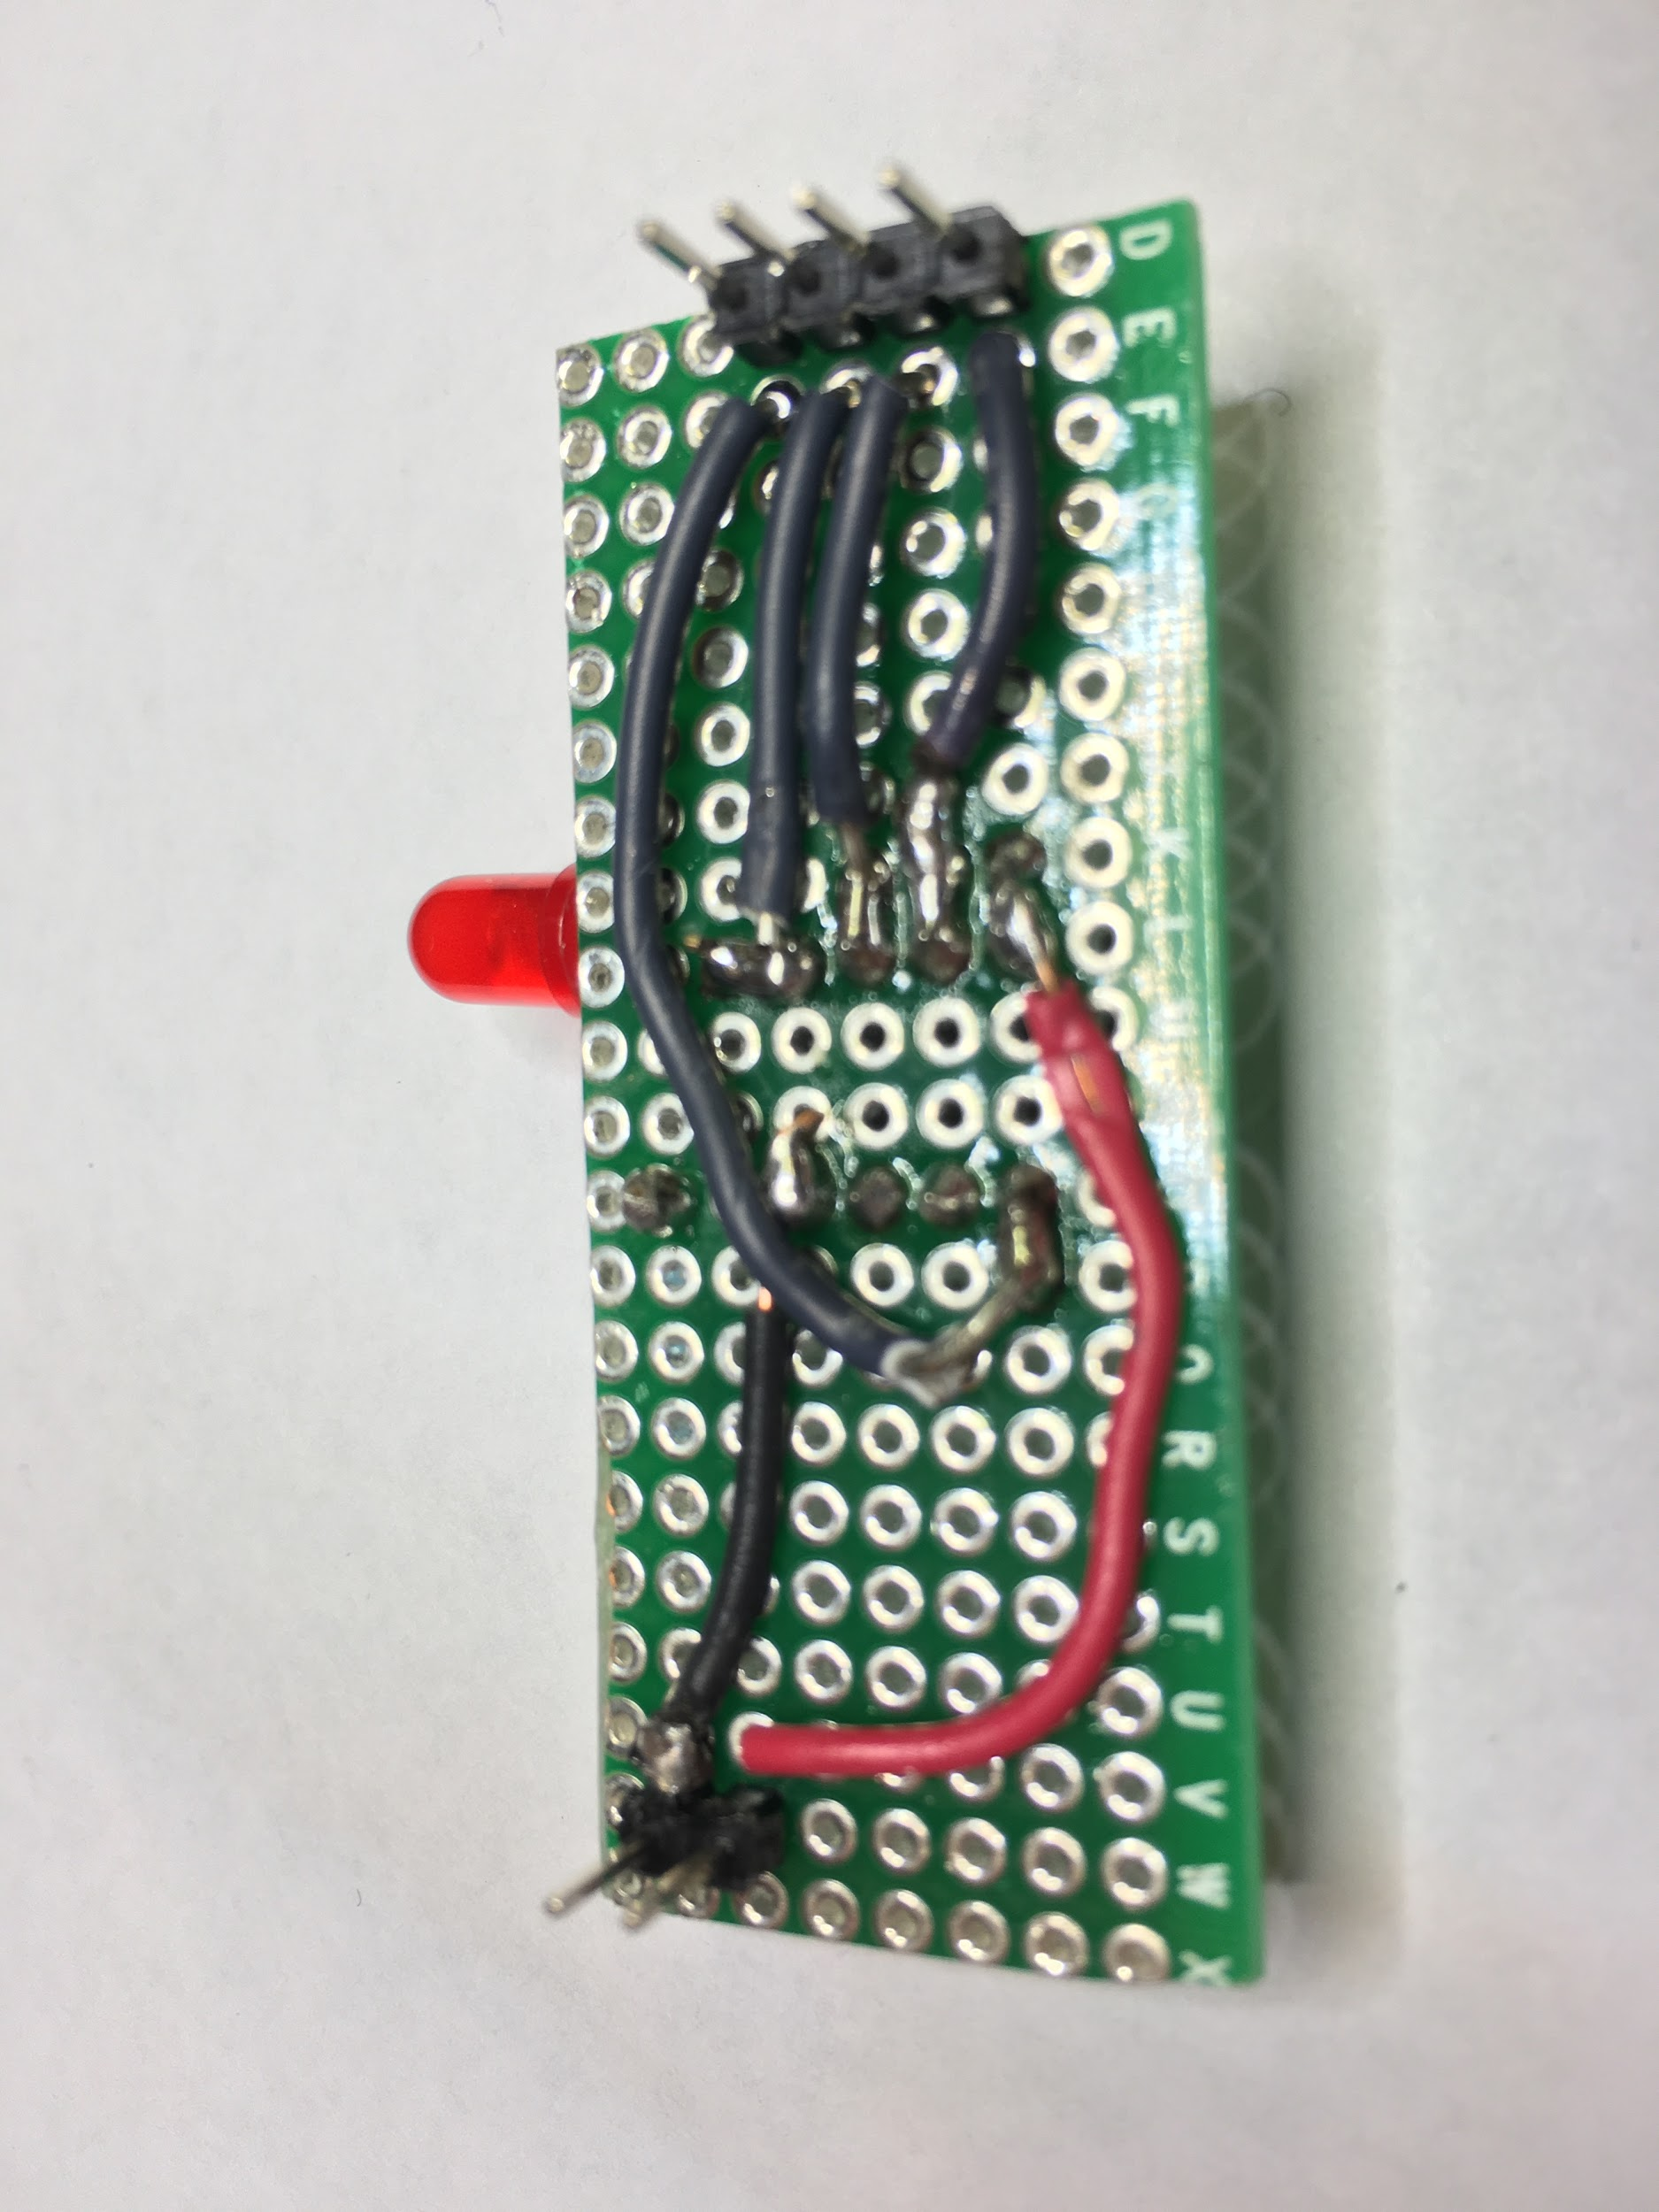

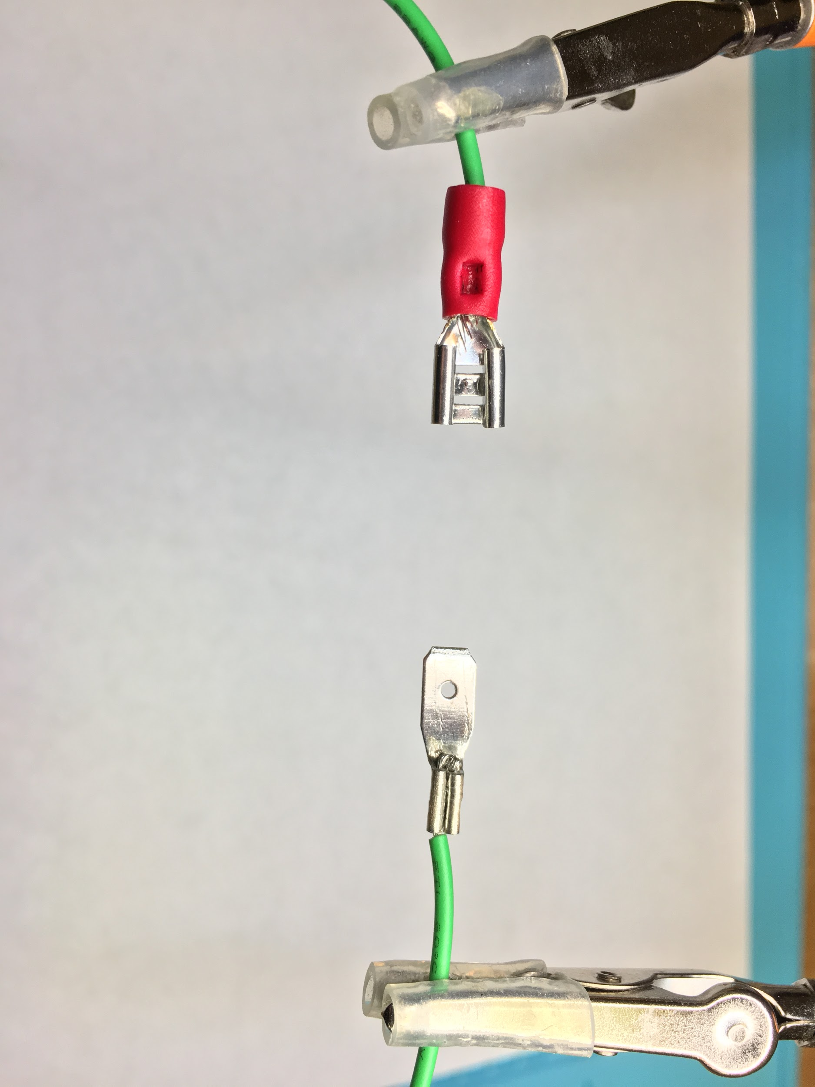

Connector system with crimped pins (Deutsch DT/DTM)

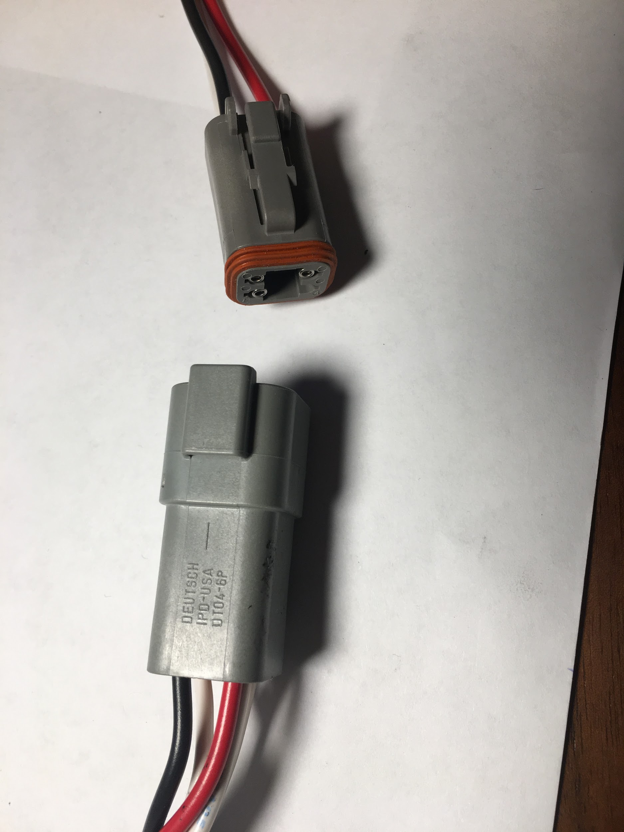

Terminal Blocks Wire nuts (110 VAC aka residential electrical)

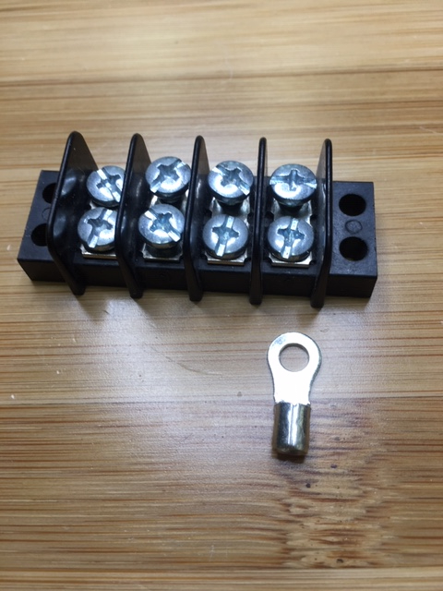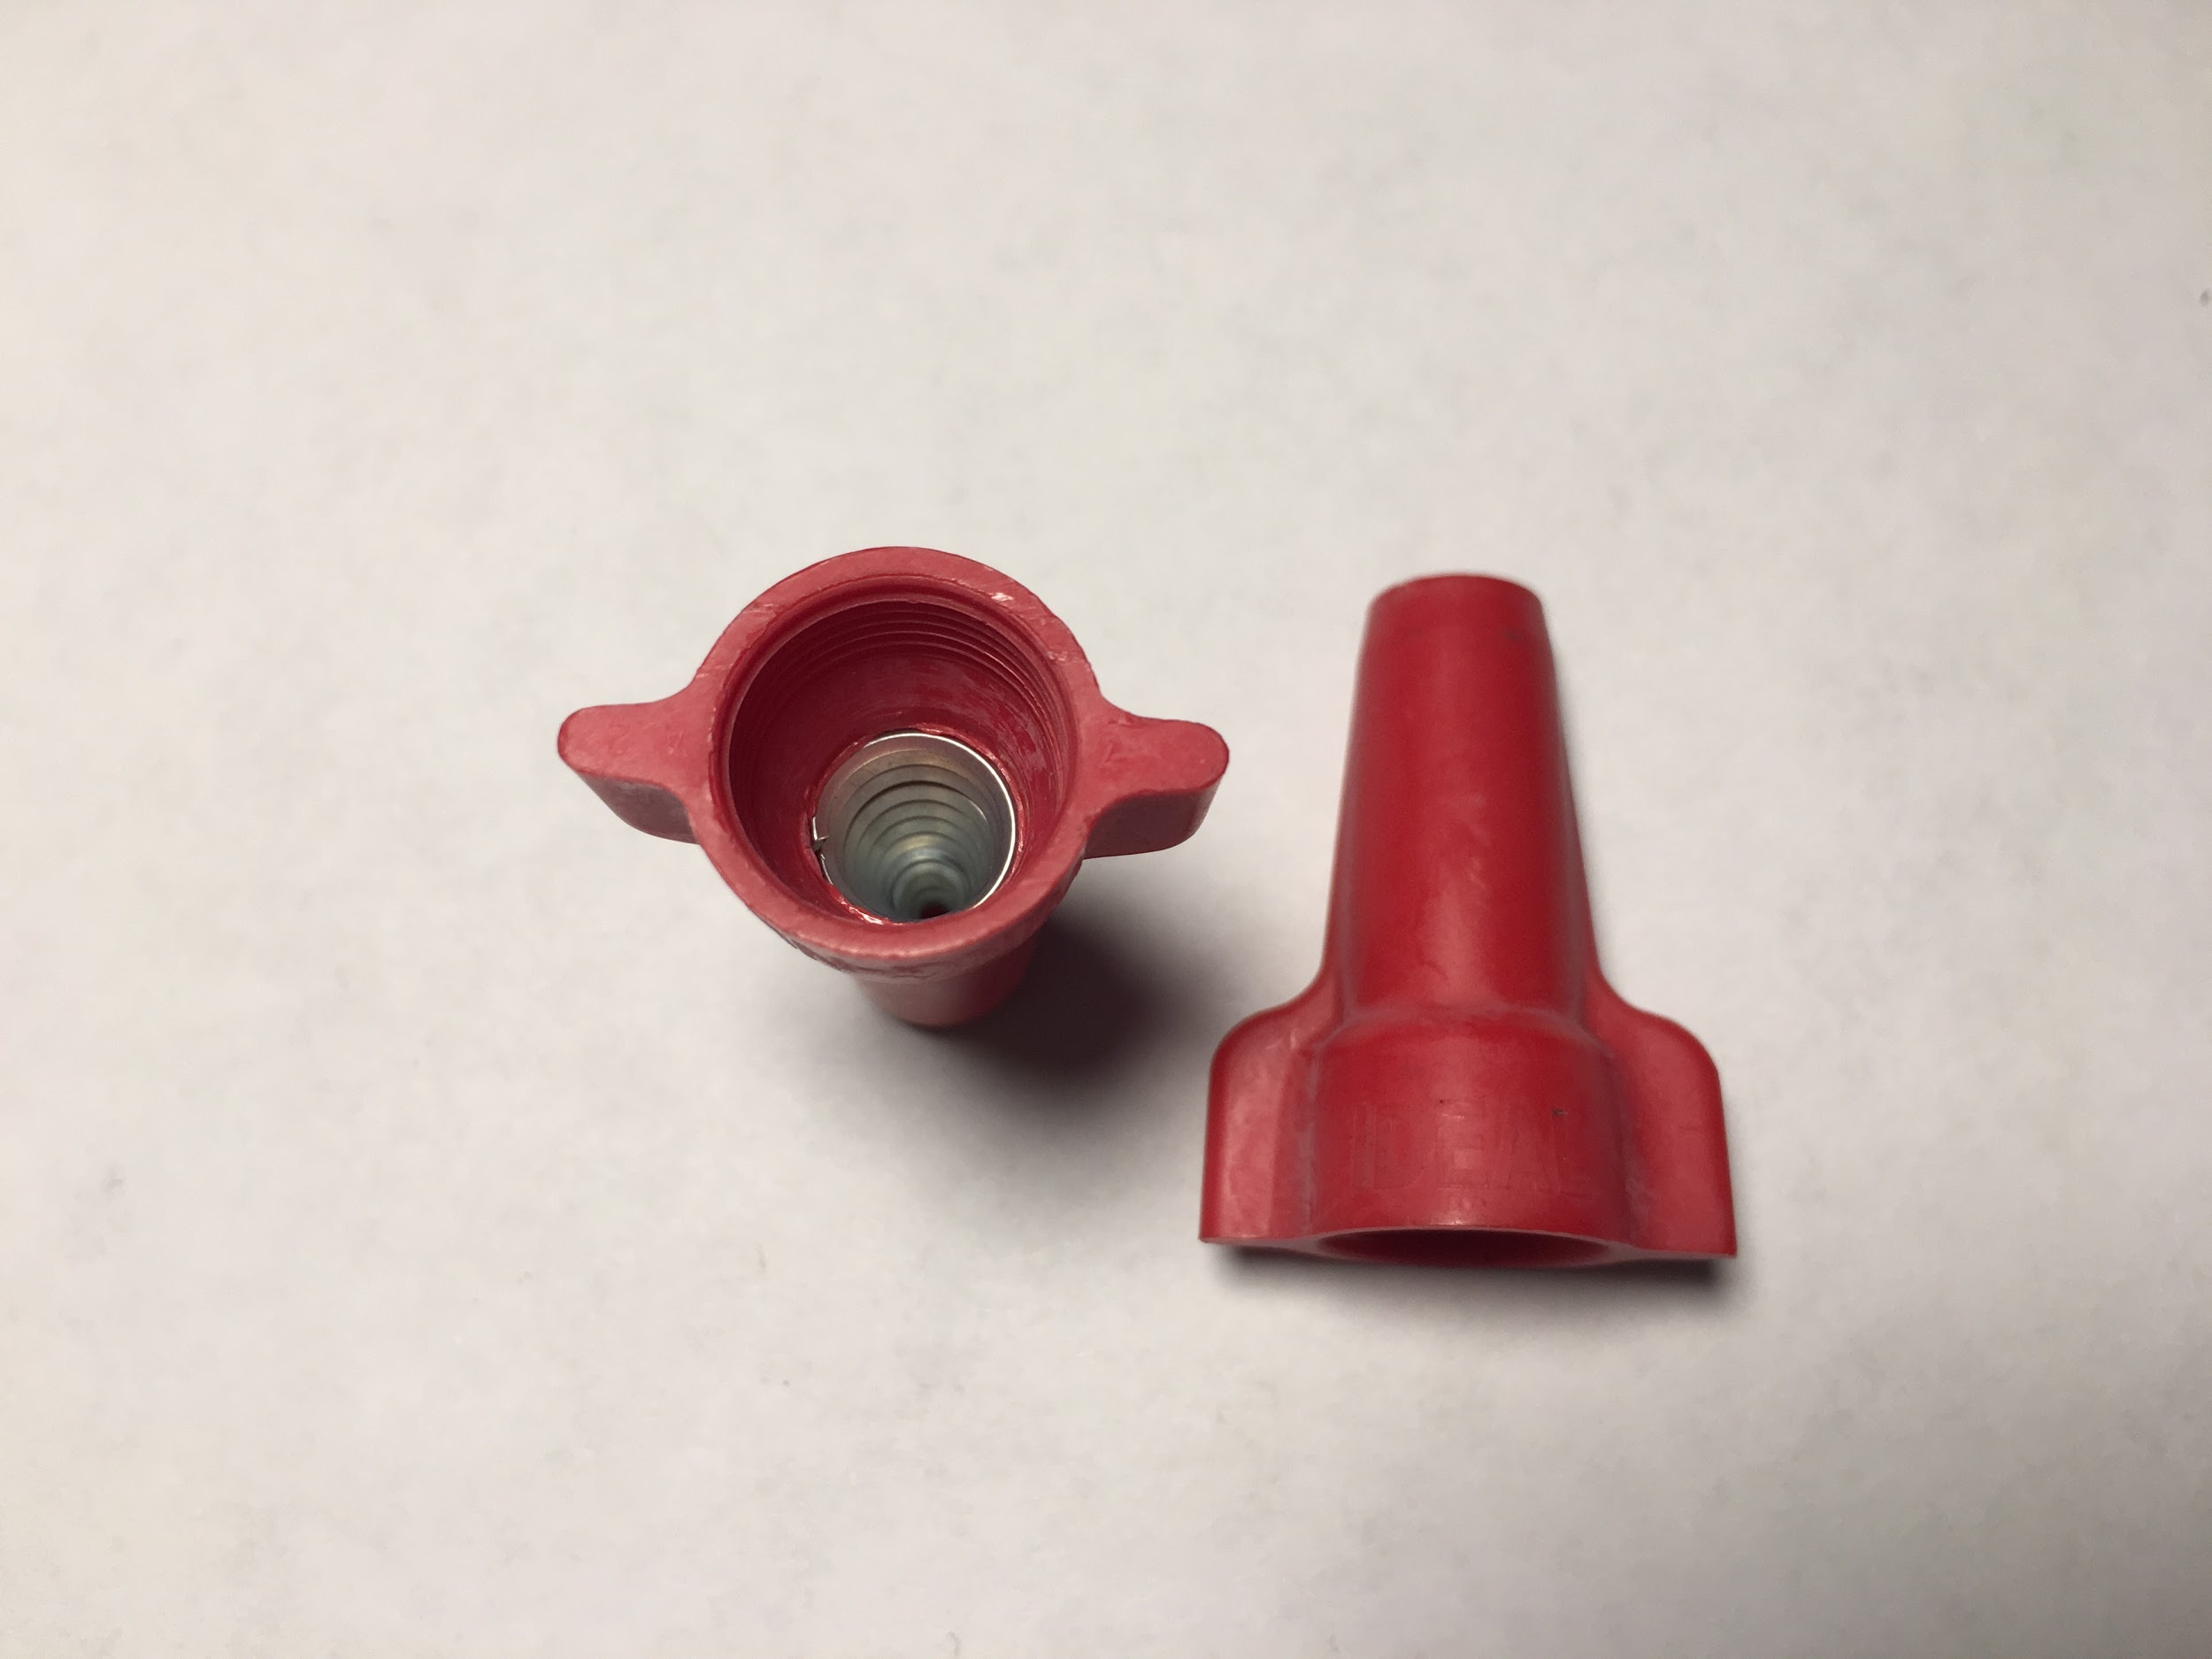

Screw Terminals Spring clamps

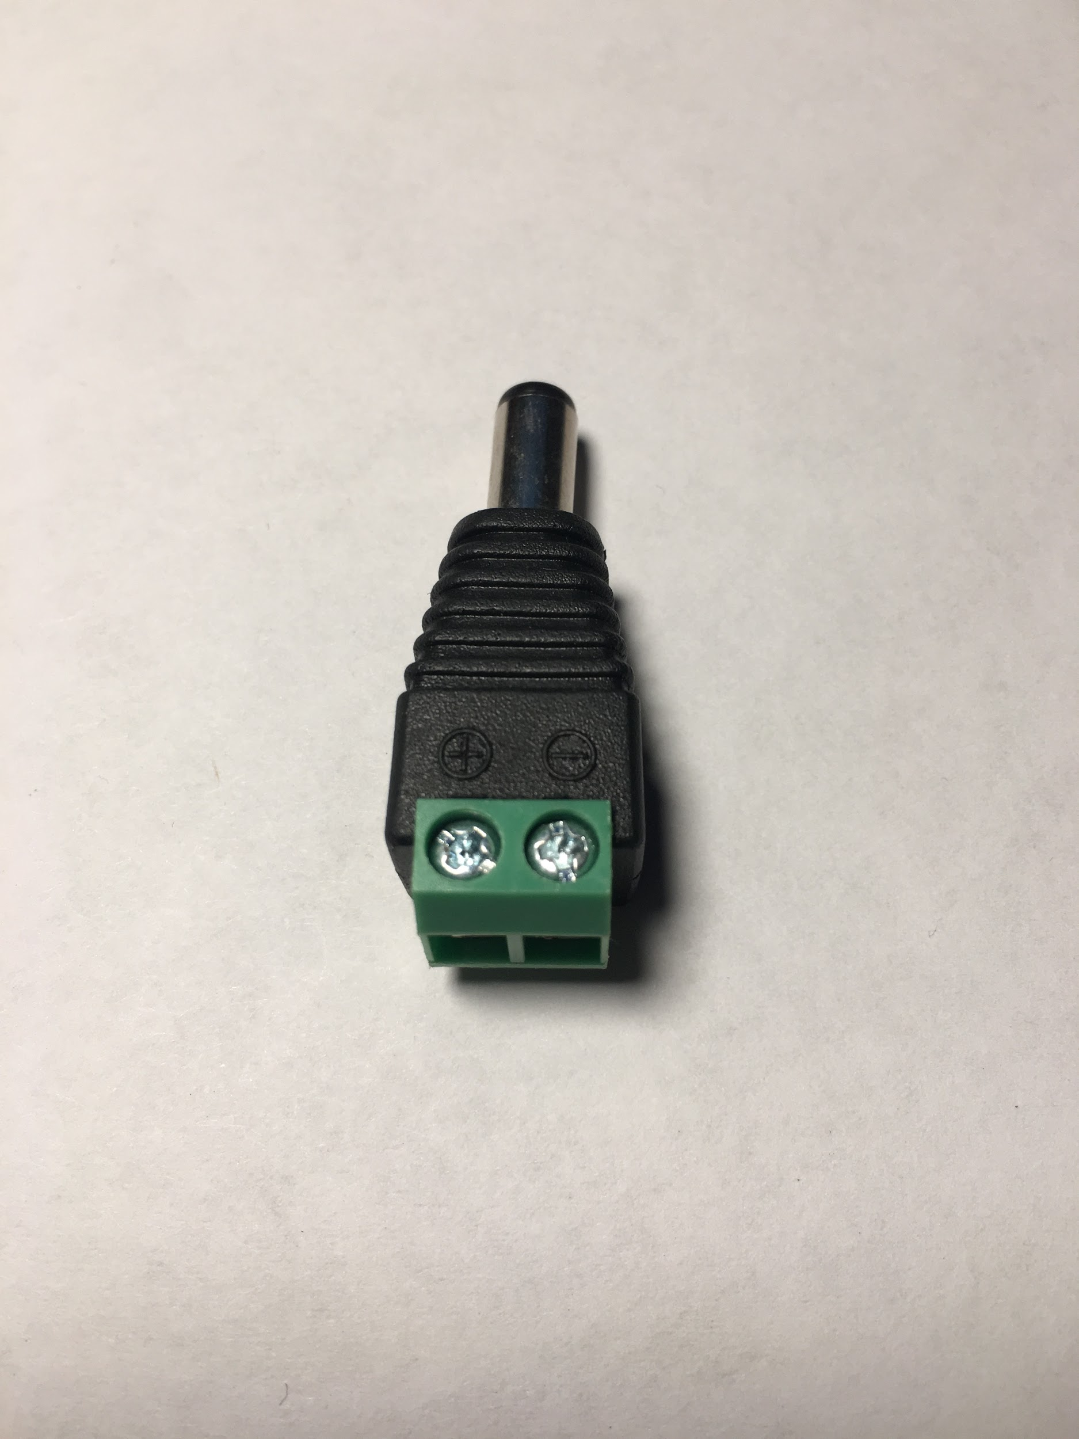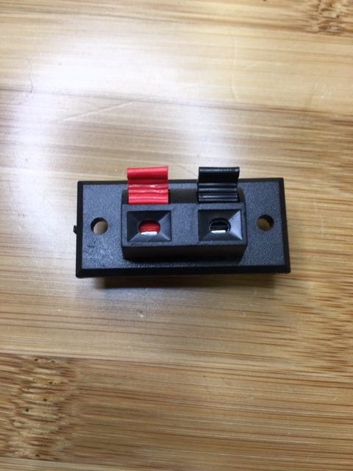

IC socket

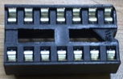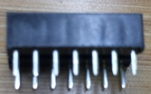

### Exercise 1: Lineman Splice

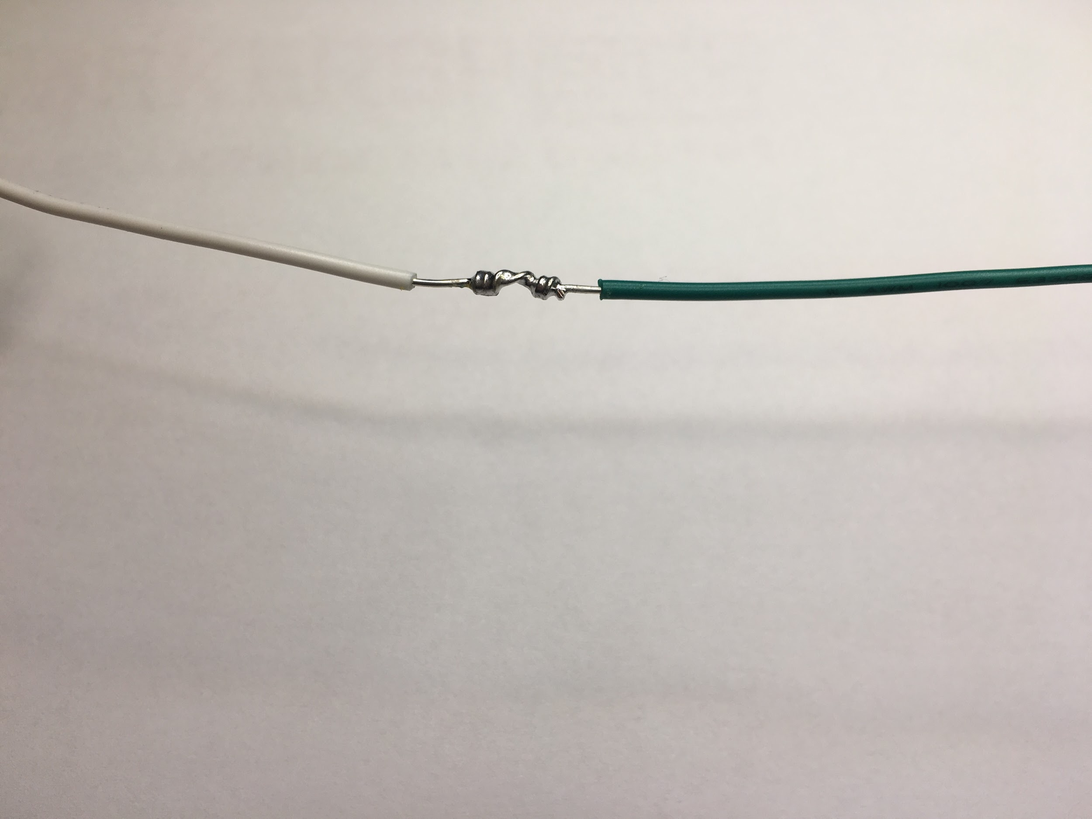

1. Setup: Soldering station with *chisel tip*, rosin core solder, damp sponge, brass mesh, safety glasses and extraction fan. Turn iron on to setting “3”, roughly (d) degrees (**insert temperature**). *(Discuss temperature (650-750 degrees and Rheostat for lower watt iron)*

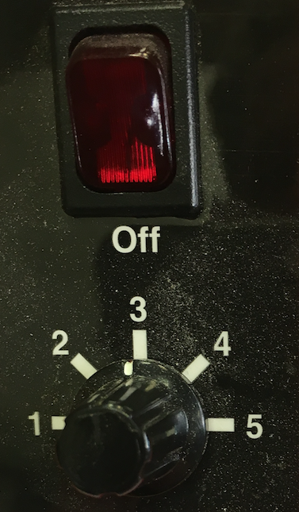

1. Parts needed: Two wires, roughly two inches in length and strip roughly ½” of sheathing from the wire ends.
2. Method:
   1. Wrap the stripped wire ends as demonstrated below. This is called the Lineman Splice. called the Lineman splice (**3 photos**)

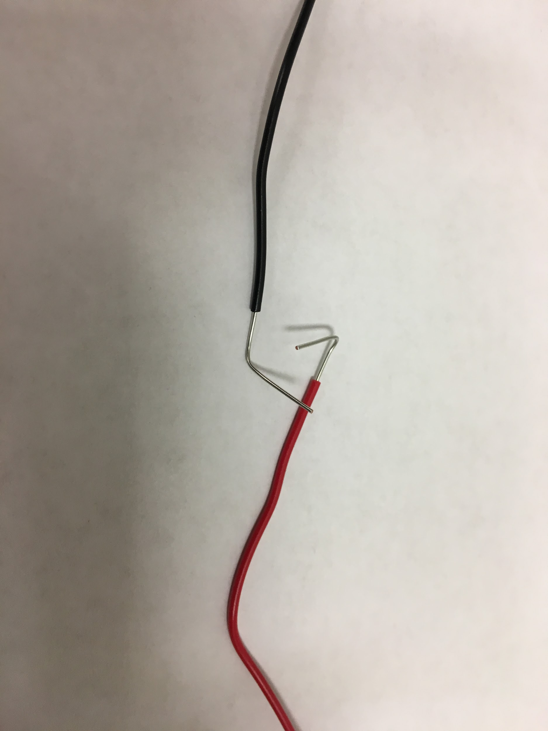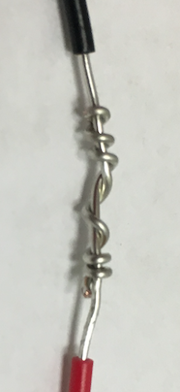

* 1. Place the wire splice into a “helping hand” tool.

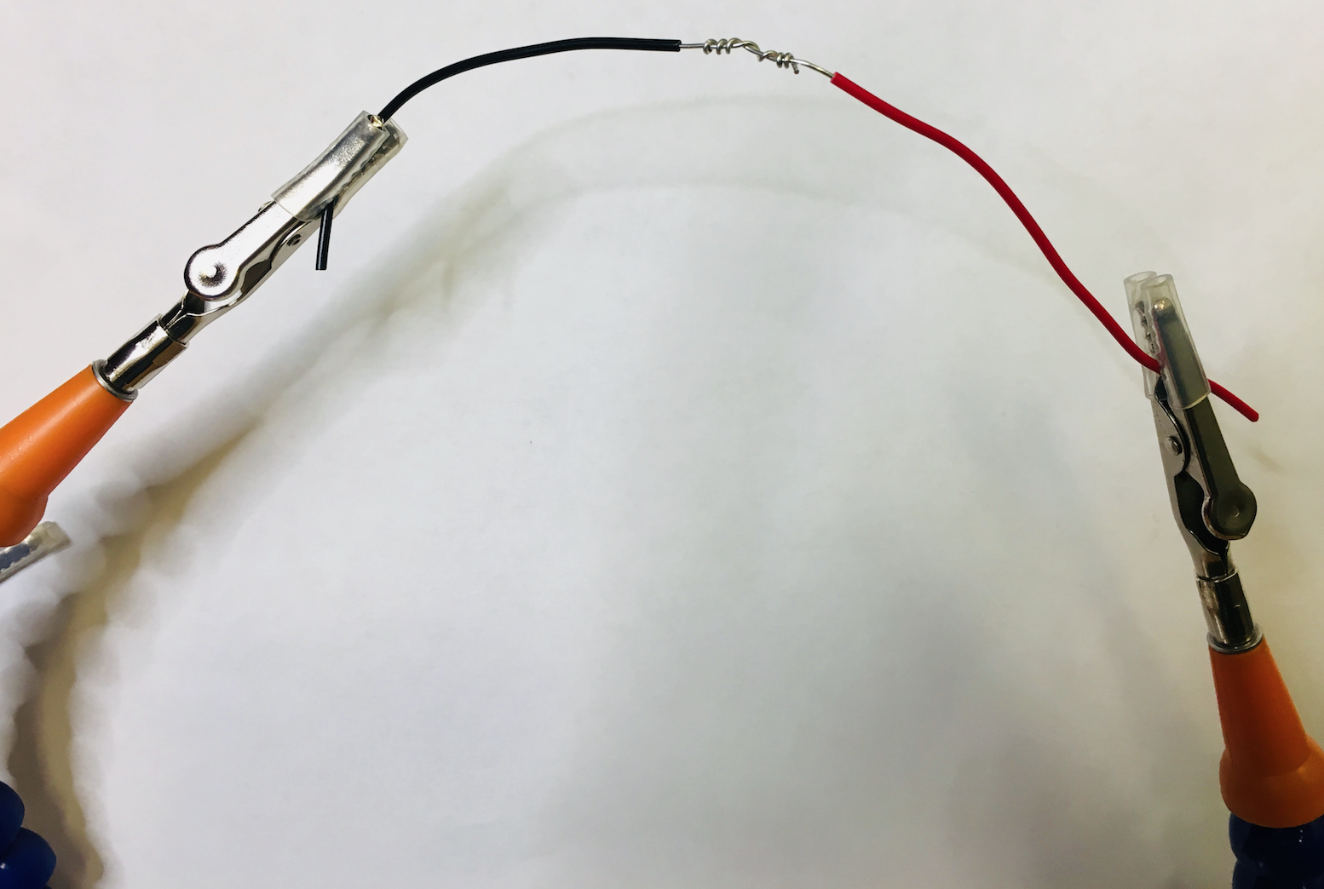

* 1. Tin the soldering iron tip.

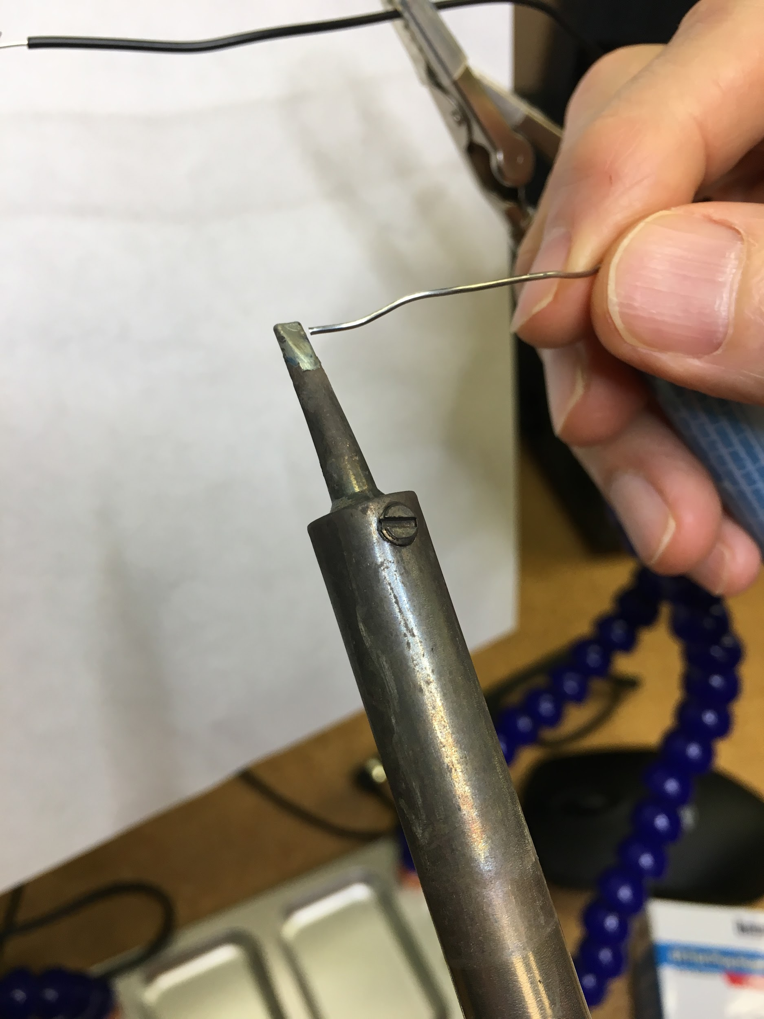

* + 1. Over-corroded tips that don’t wick solder and can’t be cleaned well with a wire sponge or wet sponge can usually be fixed using Tip Tinner. As the iron is hot, wipe the tip horizontally across the Tinner, just slowly enough to melt it.

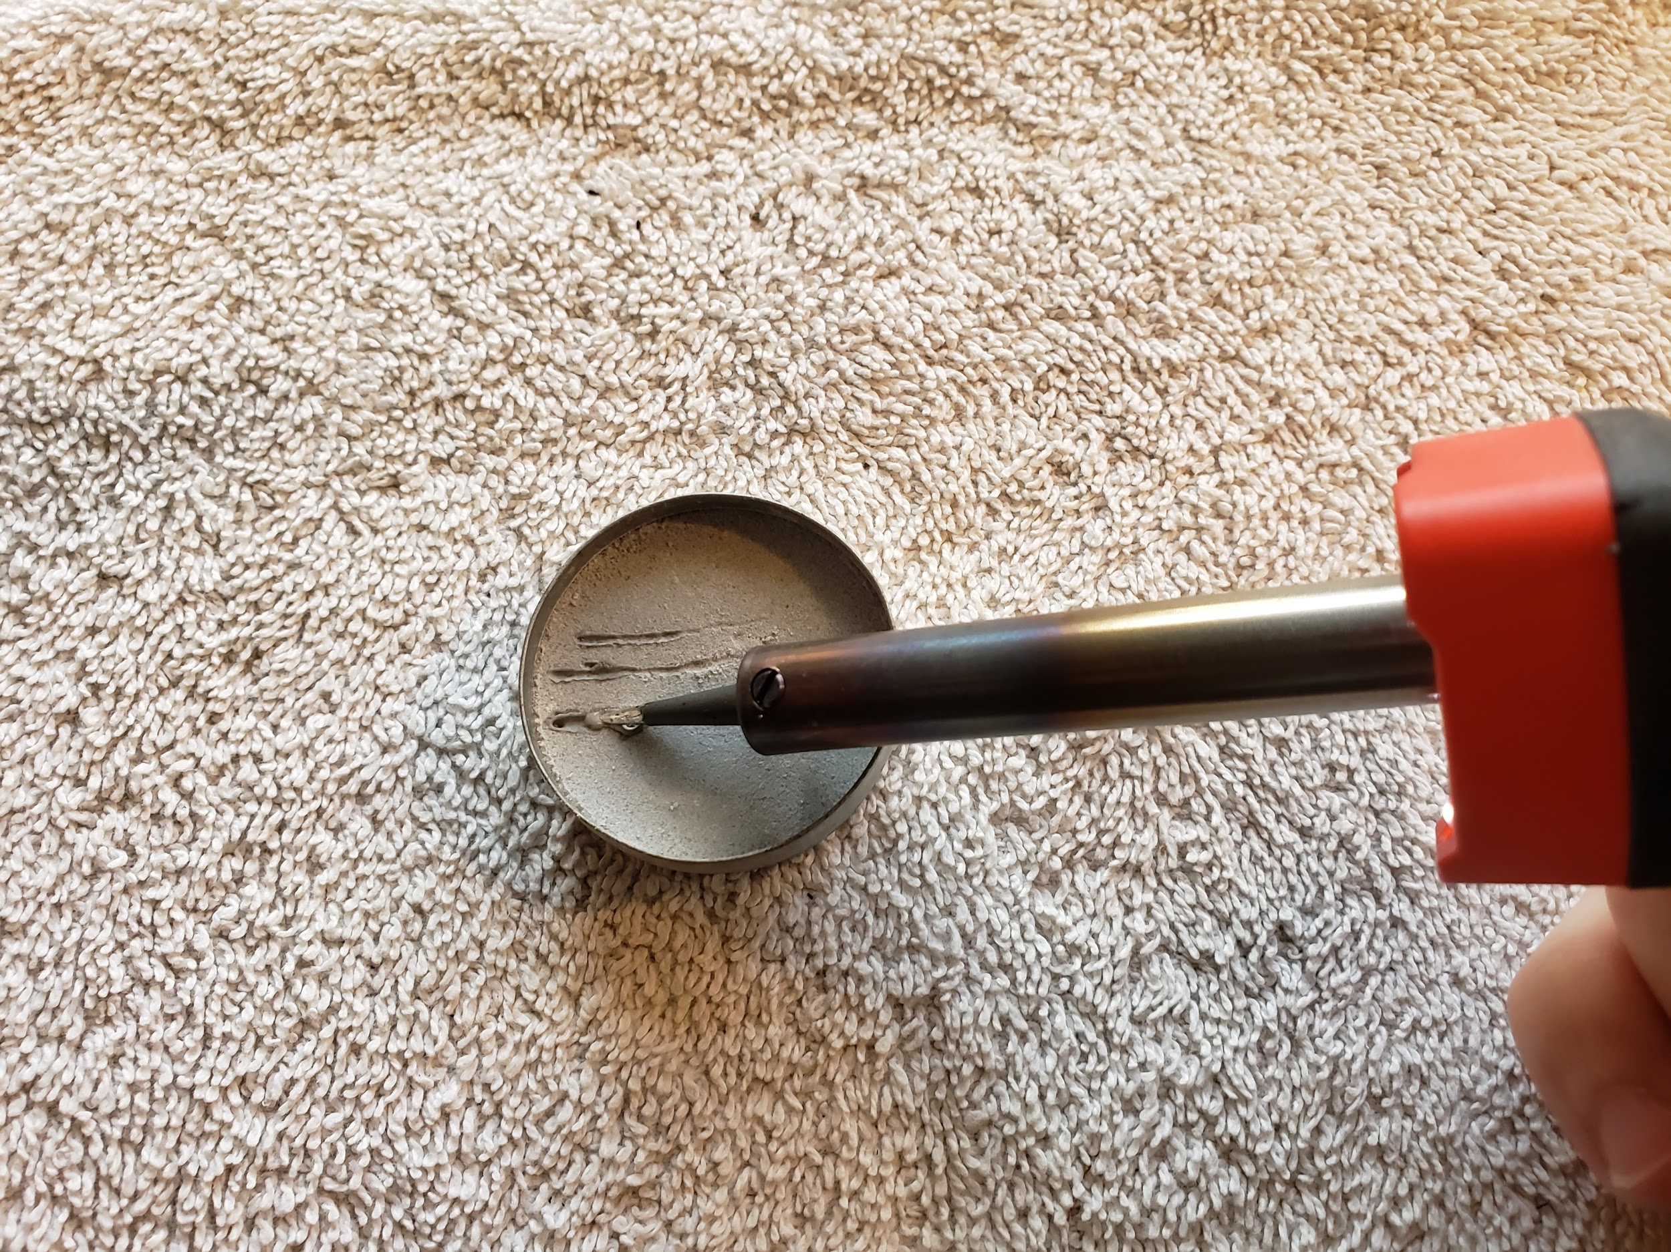

* 1. Place the hot iron underneath the splice, place solder at the top of the splice. *Don’t touch the soldering iron directly with the solder!* When heated properly the solder will melt at the top of the splice and wick into the wiring. Too much heat will cause the insulation to melt. Remove the iron as needed to keep the insulation from melting.

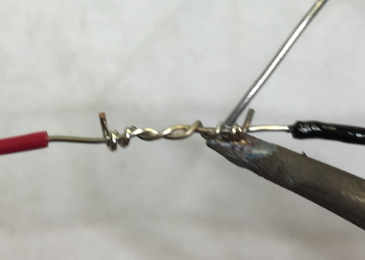

* 1. What a good solder joint looks like: Shiny with concave/beveled shapes over the wire splice. Poor solder joint is dull or clumpy, fix with the heat of the soldering iron only.

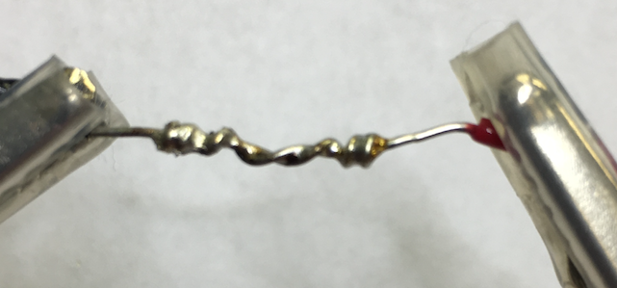

* 1. Place heat shrink tubing on the Lineman splice to demonstrate a method of returning insulation to the wire after soldering. Use a heat gun or other heat source to melt the heat shrink tubing.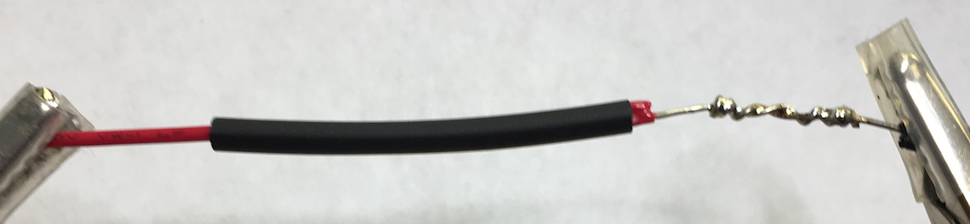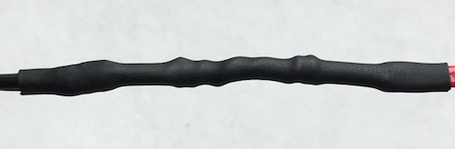

**Cool Fact**: The Lineman Splice has gone to space and is included in NASA’s electrical Workmanship Standards, found here:

<https://workmanship.nasa.gov/lib/insp/2%20books/frameset.html>



### Exercise 2: Create an LED circuit on a printed circuit board (PCB)

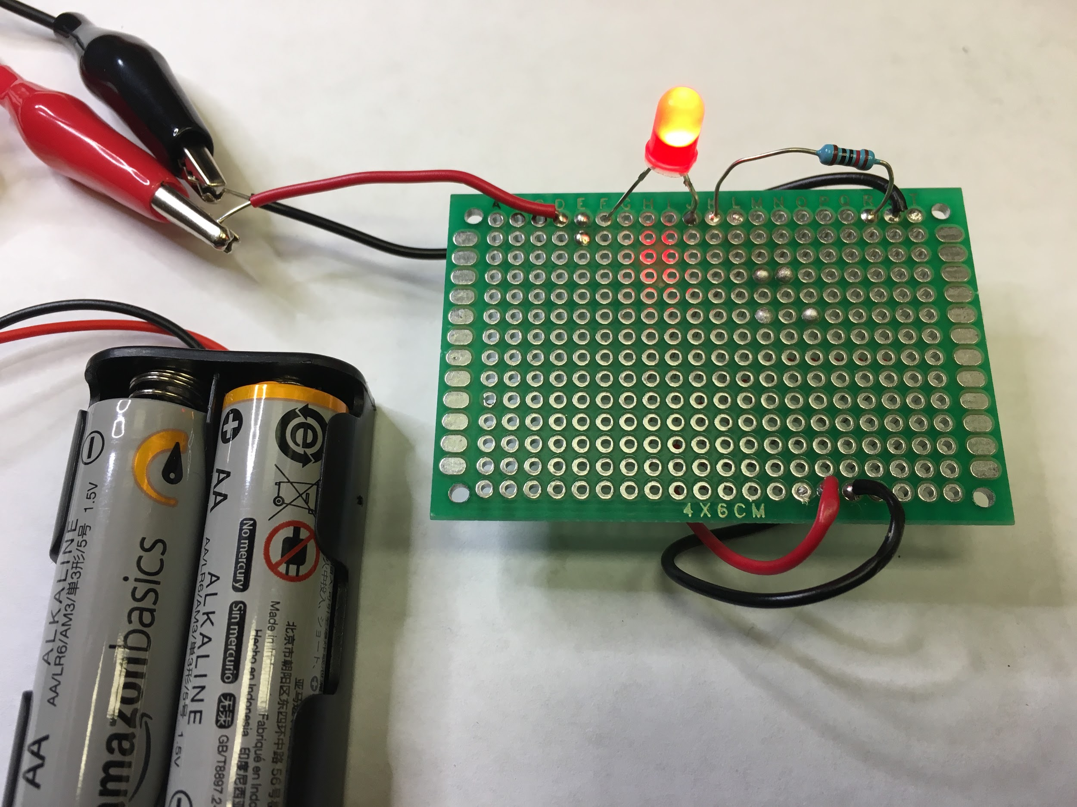

1. Setup: Soldering station with *pointed tip*, rosin core solder, damp sponge, brass mesh, safety glasses and extraction fan.
2. Parts needed: Battery holder with two AA batteries, Breadboard, (1) small prototyping PCB, (qty 1) 3V red LED, (1) 150 ohm resistor, or another ohm resistor depending on the LED current tolerance (1) red wire $≈$ 3 inch length, (1) black wire $≈$ 3 inch length. (Colors red and black are preferred but not required. Sometimes a green wire is used instead of black, or white instead of the red wire.)
3. Method:
   1. Prototype the LED circuit using a breadboard. Circuit displayed in the Fritzing diagram below: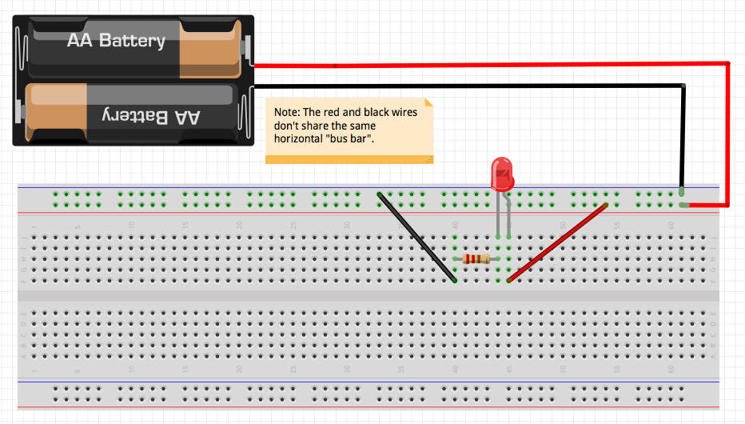
   2. Note: the LED has a long leg and a short leg. The long leg goes toward the positive (red) wire. Usually LEDs have a flat side which goes toward the negative (black) wire.
   3. Connect the battery holder wires to the breadboard black and red wires using alligator clips.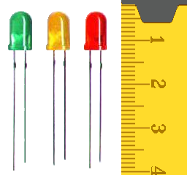
   4. Verify the LED lights up!
   5. The schematic is displayed below: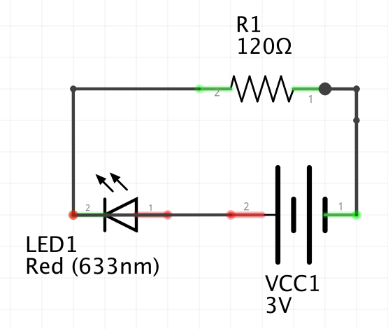
   6. Transfer the components to PCB as displayed below:

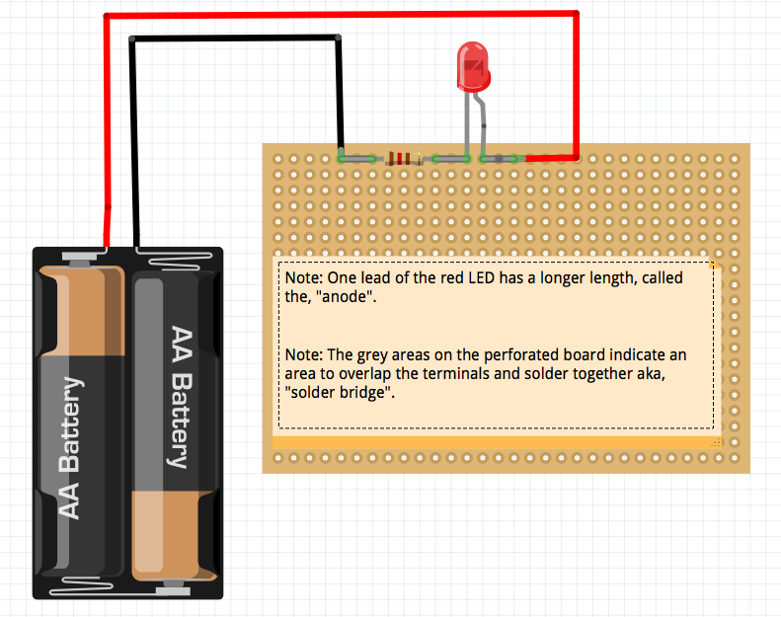

* 1. Place the components through the holes and overlap the terminals on the backside, you will solder these together, creating a “bridge”. (Note other circuit boards can have connections between points without the need to bridge the terminal leads. (*Discuss a bus-bar and jumpers) 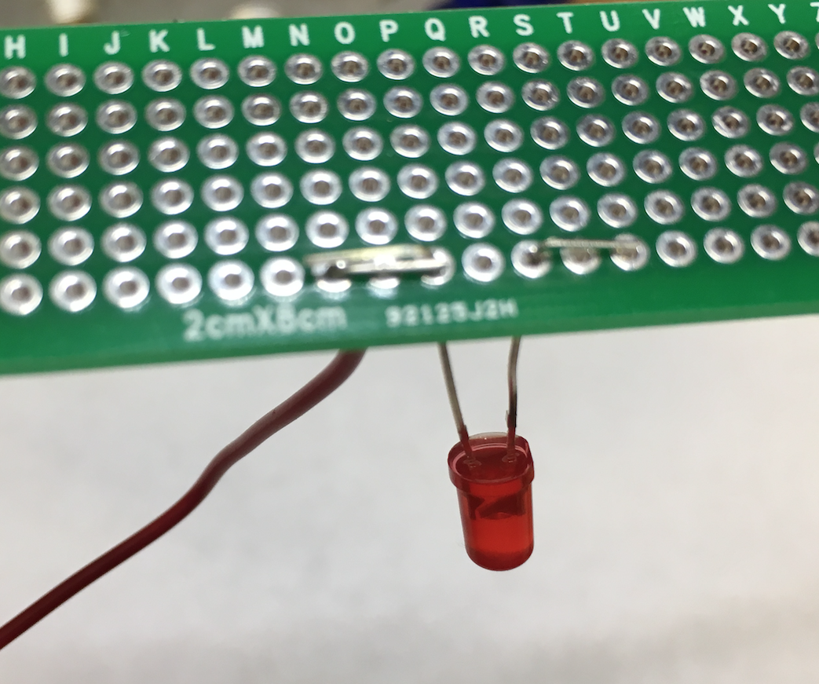*
  2. Place the iron on the solder pad touching the pad and the lead. *Don’t place the solder on the iron!* Place the solder the top of the joint and wait a few seconds for the solder to melt and wick into the splice.

*(NOTE: Keep semiconductor parts, in this case the LED, a little away from the board and use alligator clips on the leads to protect the semiconductors from heat)*

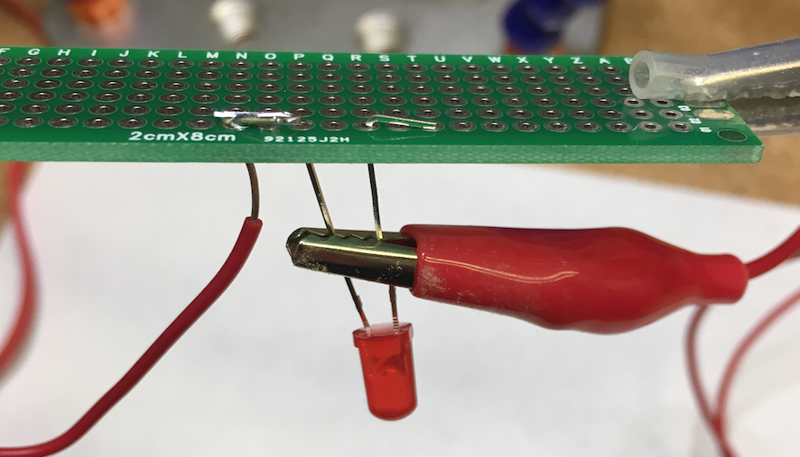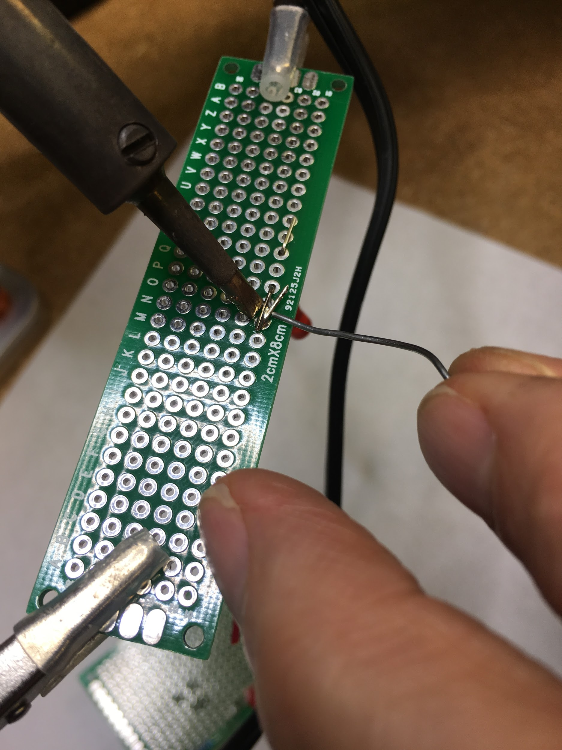

* 1. Using flux and tinning the soldering iron tip yield a cleaner result.

Note: Depending on type of flux used in solder, the PCB may need to be cleaned with alcohol or circuit board cleaner following the soldering operation.

* 1. Connect the battery holder to your circuit with alligator clips... IT’S ALIVE!



*NOTE: if your LED circuit does not illuminate, use a multimeter to check for continuity and voltage.* **(Insert link to multimeter document)**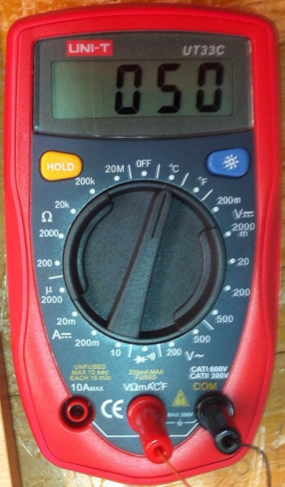

* 1. Intro to desoldering: Place and solder a wire into a random through hole on the PCB. Utilize solder wick and a desoldering pump to remove the wire. Which worked better?

Additionally, its common to use a solder rework station to desolder much smaller surface mount components.

NOTE: You can purchase a 3v coin cell from the SCC bookstore to to demonstrate your your soldering workshop!

## Want to Learn More?:

How did we know to use a 150 ohm resistor?

Ohm’s Law is a relationship between voltage (V), current (I) and resistance (R).

Ohm’s Law is generalized by: $V= I∗R$

We decided to use a 3 V battery holder and found that our red LED is rated for 20 milliamps (mA) or converted to .020 A for use in the calculation.

$3 V = (.020 A) * R$

Solve for: $R = 3 V/ (0.020 A)$

$R =$ $150 ohms$ $(Ω)$

You can learn more electronics in greater depth? See Sacramento City College course, “Electronic Technology course: ET340 or … **Insert additional courses here**”

We used free software called Fritzing to create our breadboard and PCB layouts used in exercise 2. You can find it here:

<http://fritzing.org/download/>